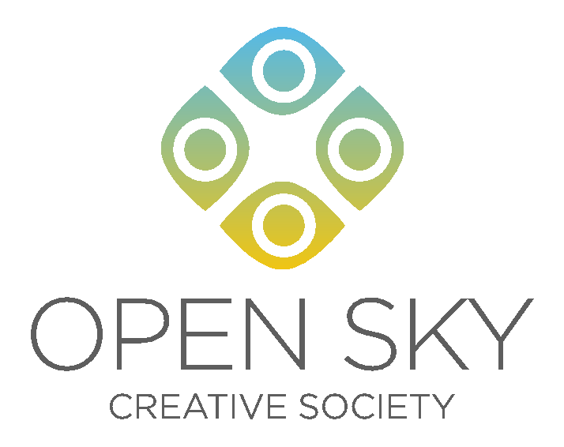

Workshop facilitation proposal for Open Sky Creative Society

The Open Sky Creative Society (OSCS) is based in Fort Simpson in the Dehcho region. The society was formed in 1999 from the collective passion of local artists and arts supporters to bring artists together and foster art, cultural traditions and creative expression in the community. Known for our annual summer festival, OSCS has grown yearly to embrace a variety of methods of fostering the arts, including workshops.
OSCS has run a number of very successful and popular workshop series that last through the fall and winter season. We are seeking artists, craftspeople, performers, musicians and other creative types who are interested in facilitating a workshop during our 2016-2017 series that will run from April until March, with the majority of the workshops taking place in the fall and winter.
We have offered a wide range of workshops in the past, everything from traditional crafts to computer game development to song writing. Some are expressly for adults, while others are designed for youth or teenagers. The workshop duration varies from half days to full days, a full weekend or a full weekend plus the adjoining Friday evening. Please outline your proposed workshop idea or ideas below with as many details as possible. Thank-you in advance for your interest.
-Return this form to Open Sky by Feb. 22-
Name:

Contact information:

Community:

Areas of expertise:

Previous workshop facilitation experience:

Proposed workshop idea(s) (Please include photos if applicable):

Target audience: (Include if participants need existing skills in order to participate ie. Basic guitar playing ability)

Workshop duration:

Number of people you can facilitate per workshop:

Estimated cost for supplies per person:

Are you willing to drive to Fort Simpson?: (Location dependent)

Are you also interested in potentially facilitating a workshop at the 2016 Open Sky Festival? (Date to be announced):

