ICEOLATION
2016 Call for Artists

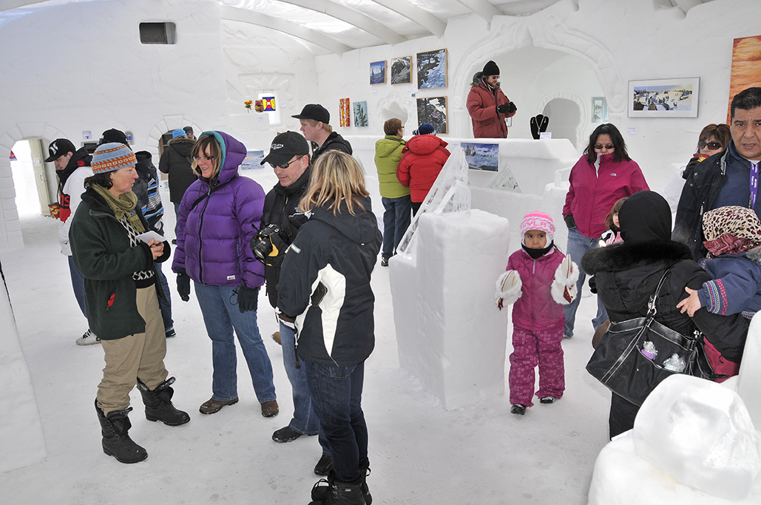

The 10th annual Iceolation Art Show opens March 19th at the Snowcastle then moves to the Down to Earth Gallery from March 20-26. Any artist, creating in any medium can submit work with an icy, snowy, or wintery theme. This is our final Iceolation Art Show so if you ever had an idea to submit this is the year. Call Down to Earth Gallery at 920-0711 or email Northsoulglass@gmail.com for more info.

