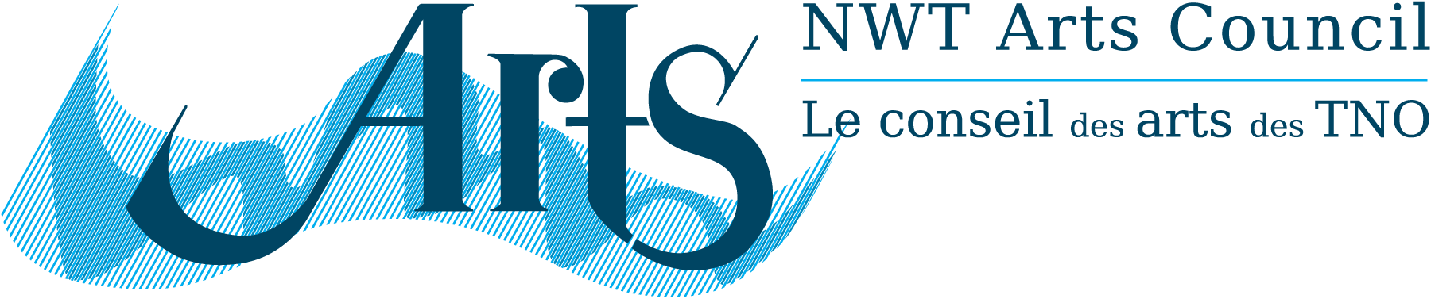

PRESS RELEASE
NWT Arts Council
April 28, 2014
Yellowknife, NWT

The NWT Arts Council is pleased to release the NWT Arts Council Strategic Plan 2014 – 2018.
“It is very exciting to now have a leading document to support the delivery of programs to the arts community in the Northwest Territories” says Winnie Cadieux (South Slave) Co-Chair of the NWT Arts Council.
The first Strategic Plan in the twenty nine year history of the NWT Arts Council lays out the Mission, Vision and Goals for the Council while detailing its strategic priorities for the next five years. The plan was prepared earlier this year by Council members in collaboration with Jane Marsland, Arts Consultant from Toronto, Ontario and Lois Little of Lutra Associates in Yellowknife.
“The Council consulted with the arts community before engaging in the planning session” says Ben Nind (North Slave) Co-Chair of the NWT Arts Council. “So many of the points raised by the community through the online survey are directly reflected in the Strategy. As we work through the tasks of the document in the near future, Council will continue to communicate with all sectors of the arts community and the public at large.”
The NWT Arts Council was established in 1985 as an advisory board to the Government of the NWT (GNWT). The legislated mandate of the NWT Arts Council is to promote the arts in the Northwest Territories.
Council members are grateful to the Honourable Minister Jackson Lafferty, Department of Education, Culture and Employment for supporting this important initiative. Copies of the NWT Arts Council Strategic Plan 2014 – 2018 are available for download at: www.nwtartscouncil.ca/news.asp

For more information please contact:
Ben Nind
North Slave
Co-Chair NWT Arts Council
(867) 444-0230

Winnie Cadieux
South Slave
Co-Chair NWT Arts Council
(867) 984-3707

Attachment: NWT Arts Council Strategic Plan 2014-2018

